WEEK 3 TASK
Advanced Data Analysis and Visualization in Logistics
Name: Bhavesh Sawant
Program: B.Sc. Computer Science
Project Area: Logistics Data Analysis

1. Objective
The objective of this task is to perform exploratory data analysis (EDA) on a hypothetical logistics dataset and use Python visualizations to understand delivery performance, shipment volume, transportation cost, and operational bottlenecks.

2. Dataset Simulation
A synthetic dataset containing 100 shipment records was created using Python. The dataset includes shipment ID, region, transport mode, shipment volume, distance, delivery time, transportation cost, and on-time delivery status.
Variable | Description | Type
Shipment_ID | Unique shipment identifier | Text
Region | North, South, East or West | Categorical
Transport_Mode | Road, Rail or Air | Categorical
Shipment_Volume | Number of shipment units | Numeric
Distance_km | Transportation distance | Numeric
Delivery_Time_days | Time required for delivery | Numeric
Transportation_Cost | Estimated transportation cost | Numeric
On_Time_Delivery | Whether delivery was on time | Categorical

3. Exploratory Data Analysis (EDA)
The dataset contains 100 shipment records. The average delivery time is 5.44 days and the average transportation cost is 1132.51. The overall on-time delivery rate is 79.0%.

Central Tendency and Descriptive Statistics
Metric | Mean | Median | Minimum | Maximum | Std. Dev.
Shipment_Volume | 287.01 | 275.00 | 51.00 | 500.00 | 123.93
Distance_km | 526.82 | 528.00 | 66.00 | 992.00 | 283.25
Delivery_Time_days | 5.44 | 5.90 | 1.00 | 7.70 | 1.60
Transportation_Cost | 1132.51 | 893.20 | 100.00 | 7568.06 | 1171.65
The mean and median values help identify the typical logistics performance. Minimum and maximum values show the operational range, while standard deviation indicates how much the shipment values vary.

Correlation Analysis
Correlation analysis was used to identify relationships between shipment volume, distance, delivery time, and transportation cost. Positive correlation indicates that two variables generally increase together.
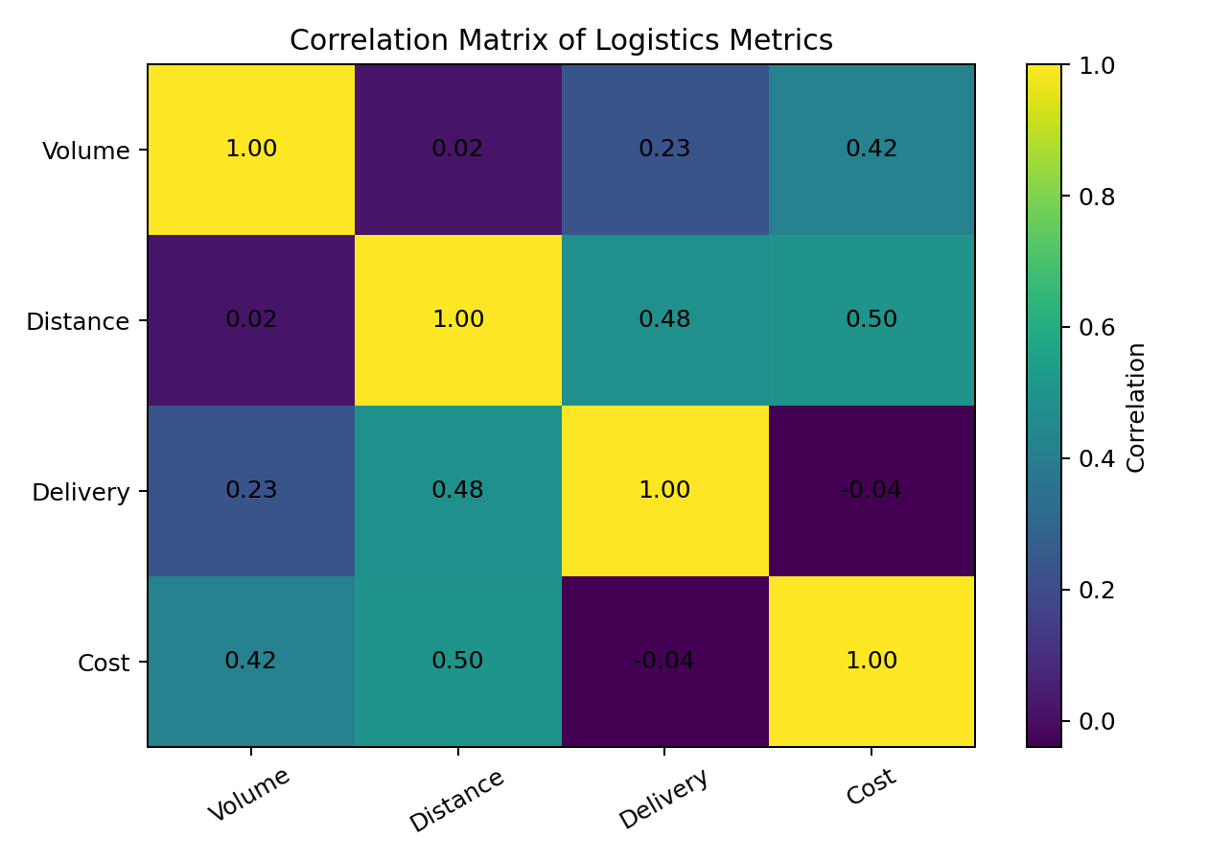

4. Visualizations and Interpretation

Delivery Time Distribution
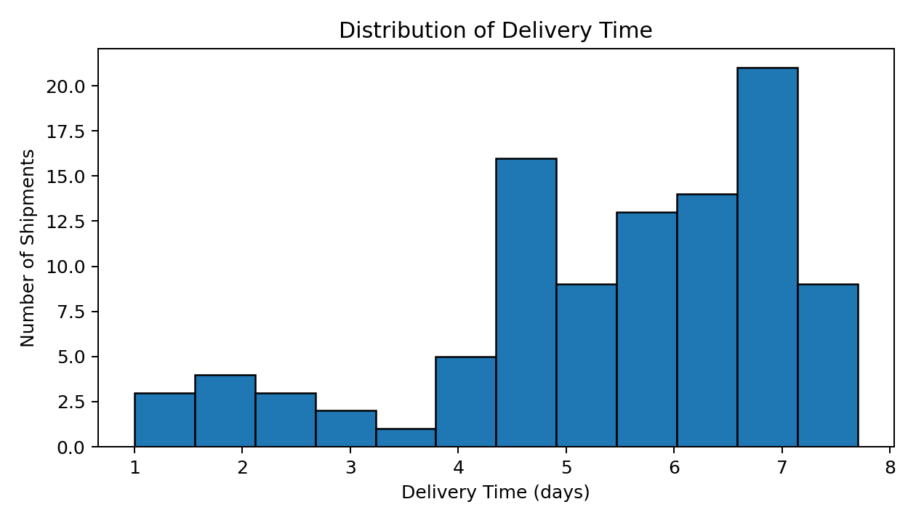
Interpretation: A histogram was selected because it shows the distribution and frequency of delivery times. It helps identify the normal delivery range and unusually long deliveries.

Transportation Cost by Mode
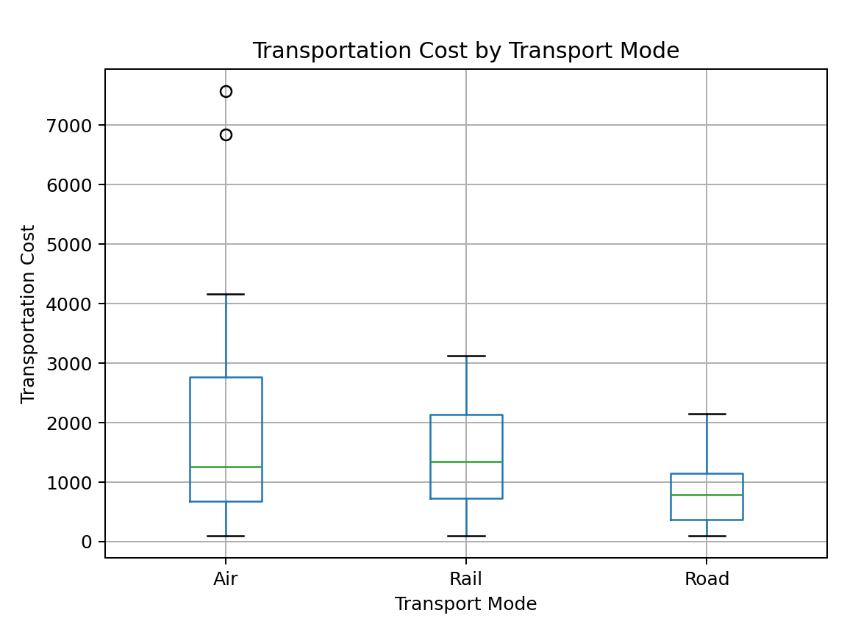
Interpretation: A box plot was used to compare cost variation across Road, Rail and Air transportation. It helps identify which transport mode is more expensive and whether there are extreme costs.

Shipment Volume vs Delivery Time
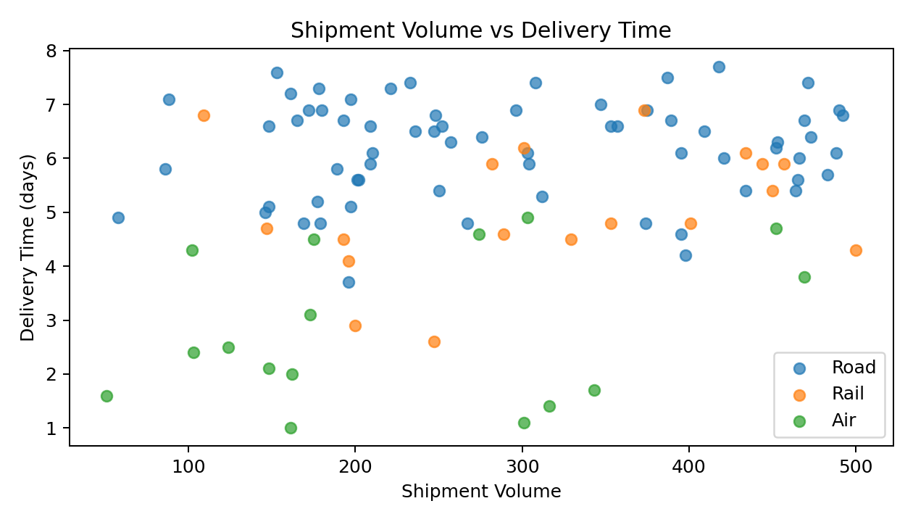
Interpretation: A scatter plot was selected to study the relationship between shipment volume and delivery time. It can reveal whether larger shipments are associated with longer delivery times.

Average Delivery Time by Region
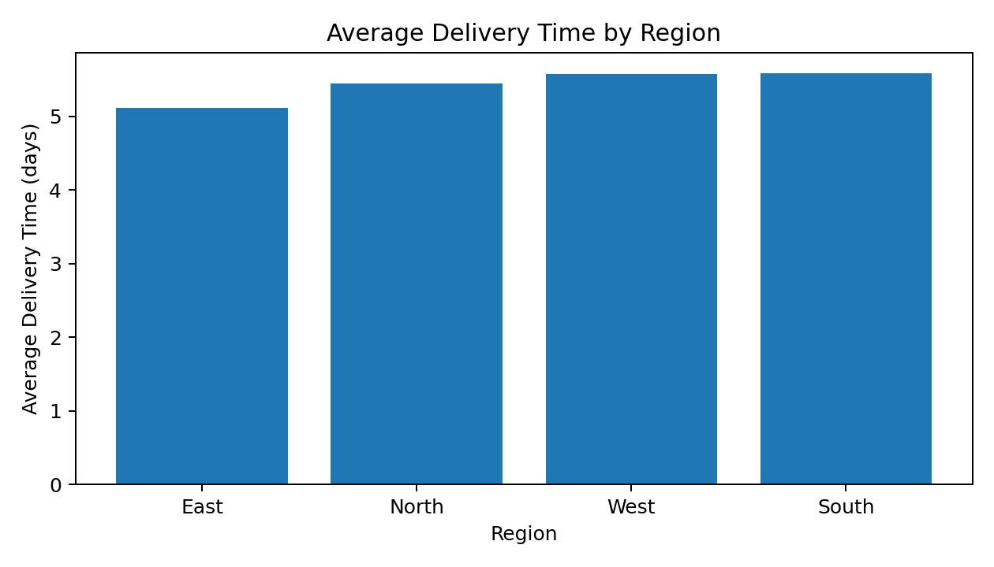
Interpretation: A bar chart was used to compare regional performance. It makes differences in average delivery time easy to identify and can highlight regions requiring operational attention.

5. Analytical Insights
1. Delivery performance: The distribution of delivery time shows the typical delivery range and highlights shipments that take longer than usual.
2. Cost drivers: Transportation mode and distance are important factors affecting transportation cost. Air transportation generally provides faster delivery but has a higher cost.
3. Shipment volume: Higher shipment volumes can increase handling and delivery time, especially when operational capacity is limited.
4. Regional bottleneck: In this simulated dataset, South has the highest average delivery time among the four regions, so it can be investigated for route, capacity, or operational issues.

6. Recommendations
- Monitor shipments with unusually high delivery times and investigate the reasons for delay.
- Compare transportation modes based on both cost and required delivery speed instead of cost alone.
- Improve route and capacity planning for regions with higher average delivery time.
- Use shipment-volume trends to plan warehouse, vehicle, and manpower requirements.
- Continue tracking on-time delivery rate as a key logistics performance indicator (KPI).

7. Python Tools and Techniques Used
Python was used for dataset generation and analysis. Pandas was used for data loading, cleaning, grouping, descriptive statistics and correlation analysis. Matplotlib was used to create histograms, box plots, scatter plots, bar charts and the correlation matrix.

8. Sample Python Code
import pandas as pd
import matplotlib.pyplot as plt
df = pd.read_csv("logistics_data_week3.csv")
print(df.describe())
print(df[["Shipment_Volume", "Distance_km",
"Delivery_Time_days", "Transportation_Cost"]].corr())
plt.hist(df["Delivery_Time_days"], bins=12, edgecolor="black")
plt.title("Distribution of Delivery Time")
plt.xlabel("Delivery Time (days)")
plt.ylabel("Number of Shipments")
plt.show()

9. Conclusion
This analysis demonstrates how exploratory data analysis and visualization can support logistics decision-making. The combination of descriptive statistics, correlation analysis, and visualizations makes it easier to understand delivery performance, cost drivers, shipment patterns, and possible bottlenecks. These insights can help logistics managers improve route planning, transportation selection, capacity planning, and on-time delivery performance.

10. Deliverables
• DOC report with analysis, charts, interpretations and recommendations.
• Python script used for the analysis and visualizations.
• CSV dataset used for the analysis.

